Robert Jiga

2 October 2020

Text Mining

HW 1

1. How many tokens and unique tokens in the text?

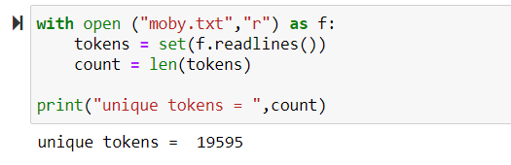

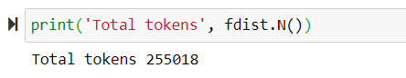

1. Apply Lammetizations to the text, count unique verbs:

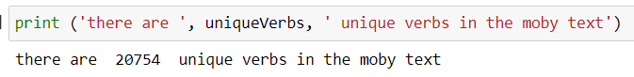

1. What percentage of tokens are “HISTORY”, “history”

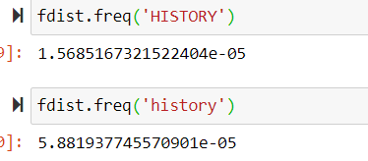

1. Top 10 most frequent tokens?



**PART 2: Spelling Recommender (Edit Distance)**

